## Steamed Chicken

Source: *Stella Chan’s Secrets in the Art of Chinese Cooking* by Stella Chan

Submitted by: Evelyn Wong

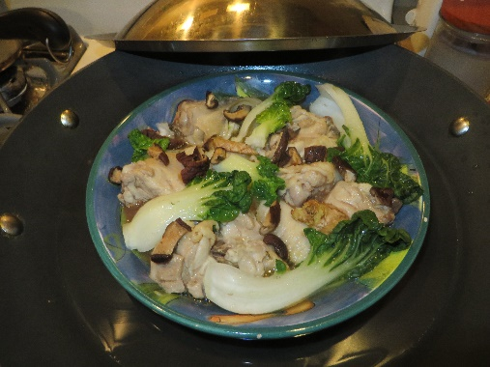

1 lb. chicken – cut into 1-inch pieces (bone included)

2 black mushrooms – soaked, sliced

2 teaspoons peanut oil

1 stalk green onion – diced

Marinade for chicken:

½ teaspoon sugar

1 teaspoon salt

¼ teaspoon MSG (optional)

1 teaspoon soy sauce

1 teaspoon corn starch

2 slices fresh ginger root – minced (1 teaspoon each slice)

½ teaspoon wine (rice wine or dry sherry)

Add marinade to chicken. Stir in 2 tsp. peanut oil. Let stand for 30 minutes. Spread chicken and mushrooms evenly in a large heatproof dish. Steam for 10 minutes. Stir well. Transfer to a serving dish. Top with diced green onion. Serve hot.

Secrets:

1. Coating the chicken with peanut oil helps to make the meat tender and juicy.
2. When steaming the chicken, make sure the dish is large enough so that the meat will be in only one layer. The meat will be cooked for a very short period of time. This way it will retain its flavor and remain tender and juicy.
3. The chicken will taste better if you steam it with the bone left in. However, if you prefer, you may steam the chicken meat without bone.

Note: You can add slices of Chinese sausage to this recipe.

From: *Lowe Family Cookbook* (2020 edition)